set ns [new Simulator]

$ns color 1 Blue

$ns color 2 Red

set nf [open out.nam w]

$ns namtrace-all $nf

proc finish {} {

global ns nf

$ns flush-trace

#Close the NAM trace file

close $nf

#Execute NAM on the trace file

exec nam out.nam &

exit 0

}

set n0 [$ns node]

set n1 [$ns node]

set n2 [$ns node]

set n3 [$ns node]

set n4 [$ns node]

$ns duplex-link $n0 $n2 2Mb 10ms DropTail

$ns duplex-link $n1 $n2 2Mb 10ms DropTail

$ns duplex-link $n2 $n3 1.7Mb 20ms DropTail

$ns duplex-link $n2 $n4 1.7Mb 11ms DropTail

$ns queue-limit $n2 $n3 10

$ns queue-limit $n2 $n4 10

$ns duplex-link-op $n0 $n2 orient right-down

$ns duplex-link-op $n1 $n2 orient right-up

$ns duplex-link-op $n2 $n3 orient right

$ns duplex-link-op $n2 $n4 orient right-down

$ns duplex-link-op $n2 $n3 queuePos 0.5

$ns duplex-link-op $n2 $n4 queuePos 0.5

set tcp [new Agent/TCP]

set tcp1 [new Agent/TCP]

$tcp set class_ 2

$ns attach-agent $n0 $tcp

set sink [new Agent/TCPSink]

$ns attach-agent $n3 $sink

$ns attach-agent $n4 $sink

$ns connect $tcp $sink

$tcp set fid_ 1

set ftp [new Application/FTP]

$ftp attach-agent $tcp

set ftp1 [new Application/FTP]

$ftp1 attach-agent $tcp1

$ftp set type_ FTP

$ftp1 set type_ FTP

set udp [new Agent/UDP]

$ns attach-agent $n1 $udp

set null [new Agent/Null]

$ns attach-agent $n3 $null

$ns attach-agent $n4 $null

$ns connect $udp $null

$udp set fid_ 2

set cbr [new Application/Traffic/CBR]

$cbr attach-agent $udp

$cbr set type_ CBR

$cbr set packet_size_ 1000

$cbr set rate_ 1mb

$cbr set random_ false

$ns at 0.1 "$cbr start"

$ns at 1.0 "$ftp start"

$ns at 4.0 "$ftp stop"

$ns at 4.5 "$cbr stop”

$ns at 5.0 "$cbr stop"

$ns at 5.0 "$ns detach-agent $n0 $tcp ; $ns detach-agent $n3 $sink"

$ns at 5.5 "finish"

#Print CBR packet size and interval

puts "CBR packet size = [$cbr set packet_size_]"

puts "CBR interval = [$cbr set interval_]"

$ns run

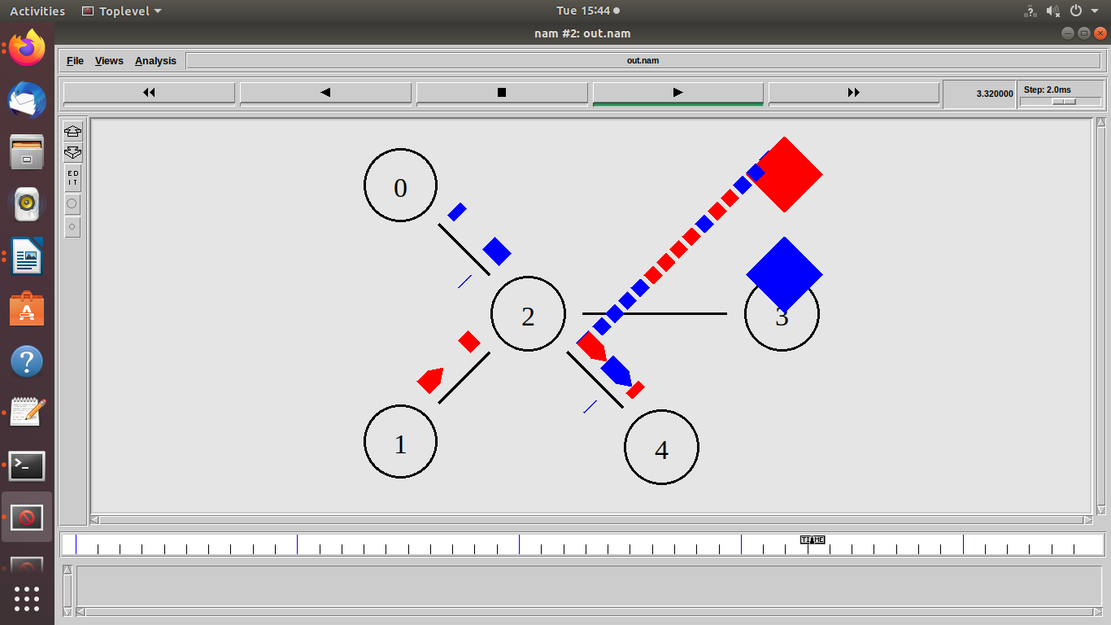

**Postlabs:**

Q. Explain Trace File Format.

A: The file written by an application (or by Coverage Server) to store coverage information or overall network information and in NS2, it is called as Trace File. It is a file that contains events logs during a simulation process. For instance, when the network simulation is run, some events happens such as packet drops and packet reception by different nodes in the network. These events are then logged in the text file and this is normally called a trace file. Events in Queues can be recorded in a trace file. Statistical information (such as throughput on a link/queue) can be computed using the trace data.

In order to generate a trace file, we have to create a file in Otcl script.